An End to End Android Messenger app (Instant Messaging) based on Wi-Fi Connectivity

**CHAPTER ONE**

**1.0 INTRODUCTION**

Instant messaging (IM) is an online real-time communication between two or more people based on typed text messages, over the internet or Local Area Network (LAN). Android based Instant Messaging is an instant messaging that is integrated or embedded in an android phone.

Android based IM has witness a tremendous growth in popularity since inception because of the advantages over a traditional IM application. Android based IM using Wi-Fi connectivity requires no application updates. It only requires an android phone that is connected to the application server via Wi-Fi to communicate with colleagues, friends, lecturers and anyone that engage himself or herself with the application. Android based IM is platform dependent, which means that it can only be used on Android operating system.

Messenger applications are very much in vogue these days. Whatsapp, WeChat, Hangouts, etc are a rage in the app world. But all these messenger applications exploit mobile data which is a paid service. Our motive was to create a messenger that facilitates communications in a small firm (Say College) free of cost to eradicate the issue of student being left out of class due to lecturers fixing classes that are not on time table.

**1.1 STATEMENT OF THE PROBLEM**

Based on the survey carried out, it was obvious that users (Students and Lectures) require a system that will enable them to conveniently and effectively disseminate class information with colleagues in real-time or non real-time, based on typed text message.

**1.2 MOTIVATION**

Traditional instant messaging applications present a lot of problems and challenges to users due to pay services. These problems restrict user’s access to cheap and convenient means of disseminating information with their colleagues, friends, and relations via a short distance. Then an idea dropped off in my mind to develop and implement an Android based IM system that will completely eliminate these problems users are experiencing so that they will have unrestricted access to free and convenient means of communicating with their colleagues, friend, and relations.

**1.3 AIM AND OBJECTIVES**

The aim of this research work is to develop and implement an android based instant messaging that will anchor students being left out from classes due to improper means of disseminating information within a school premises.

**The specific objectives are**

1. To gather necessary information on the problem caused by students being left out from classes.
2. To design an android based instant messaging app that will work using local Wi-Fi on the information been gathered
3. Evaluate the designed system
4. Implement the system

**1.4 METHODOLOGY**

Information concerning students being left out from classes is as a result of what students were facing in Adeleke University, ede due to inefficient information dissemination. Information will be gathered from the school. The design of an android based instant messaging app will be based on the information gathered and the design will be done using the flow chart system and the design system will be implemented using Android studio while PHP and MYSQL database will be used as the back end.

**1.5 SIGNIFICANCE OF THE STUDY**

The significance of this study is in the value of implementing the new system. The study will solve the problem of information dissemination.

**1.6 SCOPE OF THE STUDY**

The proposed will cover end to end chatting process as it is done in the normal traditional instant messaging applications but this proposed system will focus on Adeleke University. The means of4 connection to this application will be through Wi-Fi local Area Network (LAN). The system is expected to have the following features.

Platform dependent: The system will be platform dependent. It will only work in any android operating system.

Text chat: The system will support real-time communication between two or more people over the LAN based of typed messages (text).

Presence awareness: The system will support presence awareness feature.

**1.7 DEFINITIONS OF TERMS**

For more explanation on this project work, the following terms was extracted from this project to enable anyone to understand and have knowledge of this topic. These includes:-

* **Development:** This is describing as events that cause change. A system in which a work place or process has been converted to one that replace or minimizes human labor with electronic or mechanical equipment.
* **Data:** is a representation of facts, concepts and instructions presented in a formalized manner suitable for communication, interpretation or processing by human beings or by automatic means.
* **Mysql:** This is term My Structural Query Language which is a language for querying a database.
* **Phpmyadmin:** This is one of the packages that came with web server for database creation.
* **PHP: PHP** (recursive acronym for **PHP**: Hypertext Preprocessor) is a widely-used open source general-purpose scripting language that is especially suited for web development and can be embedded into HTML.
* **Database:** A **database** is a collection of information that is organized so that it can be easily accessed, managed and updated. Data is organized into rows, columns and tables, and it is indexed to make it easier to find relevant information.
* **Web server:** A **web server** is a computer system that processes requests via HTTP, the basic network protocol used to distribute information on the World Wide **Web**. The term can refer to the entire system, or specifically to the software that accepts and supervises the HTTP requests.
* **Information System:** It is a collection of procedures, people, instructions and equipment to produce information in a useful form.
* **Broadcast Receivers:** A broadcast receiver is a component that responds to system-wide broadcast announcements. Three of the four component types—activities, services, and broadcast receivers are activated by an asynchronous message called an *intent*. Intents bind individual components to each other at runtime.
* **Services:** A serviceis a component that runs in the background to perform long-running operations or to perform work for remote processes. A service does not provide a user interface. Example: a service might play music in the background while the user is in a different application. An activity can start the service and let it run or bind to it in order to interact with it.
* **Activities:** An activity represents a single screen with a user interface. A multi-screen application will consist of a number of activities that work together to form a cohesive user experience. However, each activity is independent of others. An application can start any one of these activities.
* **Architecture:** The proposed Instant Message Application uses a Client/Server architecture. The database and web server are on the same machine in this project, but it can also be hosted on different machines. The client can run the application in any other computer, communicate with the server via the network.
* **Database server:** This is a computer that holds the actual database and run only the DBMS and related software.
* **Data structure:** This optimized to deal with very large amounts of data stored on a permanent data storage device (which implies relatively slow access compared to volatile main memory).
* **Querying:** Querying is the process of requesting attribute information from various perspectives and combinations of factors.
* **Modules:** This is an independent or self-contained program.

**CHAPTER TWO**

**2.0 LITERATURE REVIEW**

Technology trends in both hardware and software have driven the hardware industry towards smaller, faster and more capable mobile hand-held devices that can support a wider-range of functionality and open source operating systems. Mobile hand-held devices are popularly called smart gadgets. Adding text messaging functionality to mobile devices began to gain traction in the mobile communication services community in the early 1980s. The first action plan of the Group GSM was approved in December 1982, requesting "The services and facilities offered in the public switched telephone networks and public data networks should be available in the mobile system”. This plan included the exchange of text messages either directly between mobile stations, or transmitted via Message Handling Systems widely in use at that time. The first proposal which initiated the development of exchanging information or sent message to the user was made by a contribution of Germany and France into the GSM group meeting in February 1985 in Oslo. Initial growth was slow, with customers in 1995 sending on average only 0.4 messages per GSM customer per month.

In 2013, 6.1 trillion text messages were sent. This translates into 193000 SMS per second. While SMS reached its popularity as a personto-person messaging, another type of SMS is growing fast: application-to-person (A2P) messaging. A2P is a type of SMS sent from a subscriber to an application or sent from an application to a subscriber. It is commonly used by financial institutions, airlines, hotel booking sites, social networks, and other organizations sending SMS from their systems to their customers. According to research in 2013, A2P traffic is growing faster than P2P messaging traffic.

Over the years several approaches and solutions presented considering the secure exchanging of message thorough client and webserver. The various researches have been done and are going on location based project and in the same ratio various applications have been developed on location-based and message sharing system. As the amount of user deal to exchange the information with other people to store the large amount of data to the centralized database. Sensitive data may also be leaked accidentally due to improper disposal or resale of storage media.

Instant Messenger is a proprietary, simplified version of Internet Relay Chat, which allows two or more people to carry on a conversation, in realtime, using text based messages with context awareness. Instant Messenger is used to avoid boredom, to socialize and to maintain contact with casual acquaintances.

Some of the Mobile Messaging Applications those are generally used are:

1. Hike
2. Chat On
3. WhatsApp
4. E-buddy messenger
5. Facebook Messenger
6. G Talk
7. Go SMS Pro
8. We-chat

**2.1 BENEFITS OF A COMPUTERIZED SYSTEM**

The use of android base instant messaging using Wi-Fi for Adeleke University offers a great deal of benefits in the sense that if the school can get themselves acquainted with a computerized type of a system, the problem of students missing classes will be dealt with.

**2.2 SYSTEM INVESTIGATION**

This is the investigation carried out on the existing system to determine whether there is need for the proposed system under this, the problem of existing will be investigated and the benefit of the proposed system will be analyzed. During the course of this study, the activities related to Adeleke University will be carried out, documents will be cooked through and their transactions processes will be observed.

**2.3 SYSTEM ANALYSIS**

System analysis deals with the full description of the problem to eliminate and the objectives of the proposed system. The requirement specification can be examined and approved before system design is embarked upon. After a thorough investigation, the following problems were found to be inherent in the present of other existing system.

**Architectures**

This section provides an overview of the two main architectures which could be used to implement a chat system. For each of them, we focus on describing the advantages and disadvantages, in order to compare them and to pick the one that best suits our requirements for the Chat system. One more thing to notice is that these two architectures can also be mixed and used in ways that allow to take advantage of both of them.

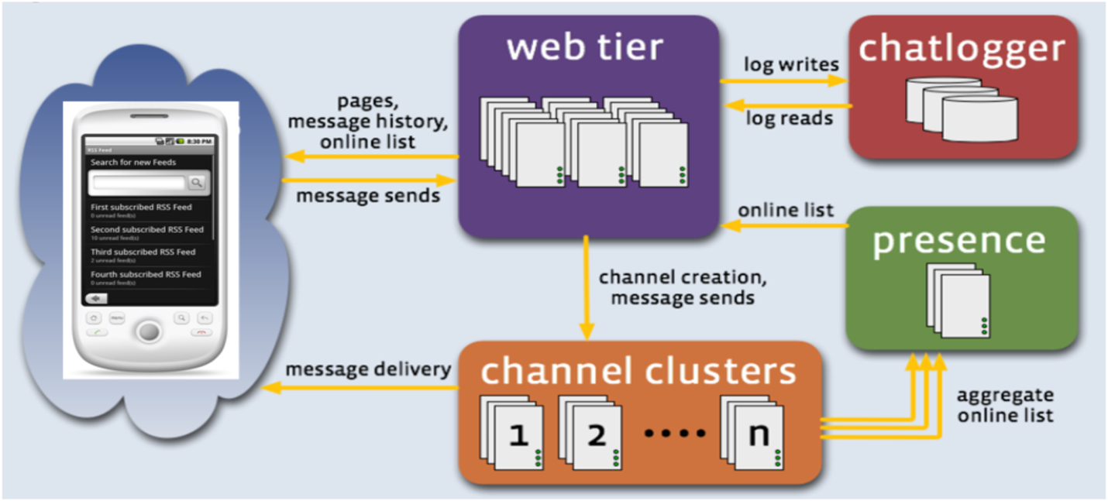

Figure 1: Proposed System architecture

**Client-Server**

The client-server model of computing is a distributed application structure that partitions tasks or workloads between the providers of a resource or service, called servers, and service requesters, called clients. Often clients and servers communicate over a computer network on separate hardware, each one of them being customized for their designed purpose, but both client and server may reside in the same system. A server machine is a host that is running one or more server programs which share their resources with clients. It often features higher-powered central processors, more memory, and larger hard disks than clients. A client does not share any of its resources. We can find a lot of different servers: for example web, FTP, Database, mail, chat and terminal servers. For example, web services are implemented on servers. For each kind of server, there is the associated client: a Web browser will be in communication with a Web server for example.

**Composition of a Client-Server network** Client devices are typically computers with network software applications installed that request and receive information over the network. Mobile devices as well as desktop computers can both function as clients. One server generally supports numerous clients, and multiple servers can be networked together in a pool to handle the increased processing load as the number of clients grows.

**How it works**

The client-server model can be used on the Internet as well as local area networks (LANs). Network clients initiate communication sessions making requests to a server (that is to say sending messages). Servers respond to their clients by acting on each request and returning results. Thus, they are able to provide a function or a service. Functions can be e-mail exchanges, web accesses and Database accesses. Many business applications being written today use the client-server model, as well as the Internet's main application protocols, such as HTTP, SMTP, Telnet, and DNS.

**Advantages and Disadvantages**

**Advantages**

1. Because a client-server architecture enables the roles and responsibilities of a computing system to be distributed among several independent computers that are known to each other only through a network we have an additional advantage to use this architecture: greater ease of maintenance. For example, it is possible to replace, repair, upgrade, or even relocate a server while its clients remain both unaware and una  
   ected by that change.
2. Since data storage is centralized, updates to that data are easy to administrate.
3. Client-server networks generally offer advantages in keeping data secure. In fact all data is stored on the servers, which generally have far greater security controls than most clients. Servers can better control access and resources, to guarantee that only those clients with the appropriate permissions may access and change data.

**Disadvantages**

1. As the number of simultaneous client's requests to a given server increases, the server can become overloaded.

2. The client-server paradigm lacks robustness. With this model, if clients' requests cannot be full led, resources are not available anymore. More precisely, clients could not access to the data from the server. If it is a mail server, persons running clients will not be able to access to their mail anymore.

**XMPP (eXtensible Messaging and Presence Protocol)**

XMPP (also known as Jabber) is a technology for real-time communication. XMPP is an open technology for streaming XML over a network. It is well-known and it is intended for instant messaging but it can be used for developing other type of P2P applications. The connecting peers are able to receive presence information about other peers.

**XMPP security considerations**

The following information come from the XMPP standards foundation [34] and Wikipedia.

Authentication and Encryption XMPP networks use:

* TLS (Transport Layer Security) for channel encryption. TLS is a cryptographic protocol

that provides confidentiality and integrity of exchanged data. It uses symmetric cryptography

for privacy and a keyed message authentication code for message reliability.

* SASL (Simple Authentication and Security Layer) for authentification. SASL is a framework for authentication and authorization. It decouples authentication mechanisms from application protocols, allowing any authentication mechanism supported by SASL to be used from any application protocol capable of using SASL. Authentication mechanisms can also provide a layer of data integrity that can provide services for data security and confidentiality of data.
* DNS (Domain Name System) for validation of server hostnames. DNS allows establish a correspondence between an IP address and a domain name and more generally to find information from a domain name.

These 3 different technologies allow to ensure the identity of sending entities and to encrypt XML streams. The uses of TLS and SASL for the XML stream have to be negotiated to secure communication between serverless entities. Sometimes an entity can accept an unencrypted and unauthenticated channel and in this case the client has to warn the user that the channel is neither authenticated nor encrypted.